---1 Tulis query untuk mendapatkan jumlah customer tiap bulan yang melakukan order pada tahun 1997.

SELECT MONTH(OrderDate) AS bulan,

COUNT( DISTINCT CustomerID) AS total_customer

FROM Northwind.dbo.Orders

WHERE year(OrderDate) = 1997

GROUP BY MONTH(OrderDate) ;

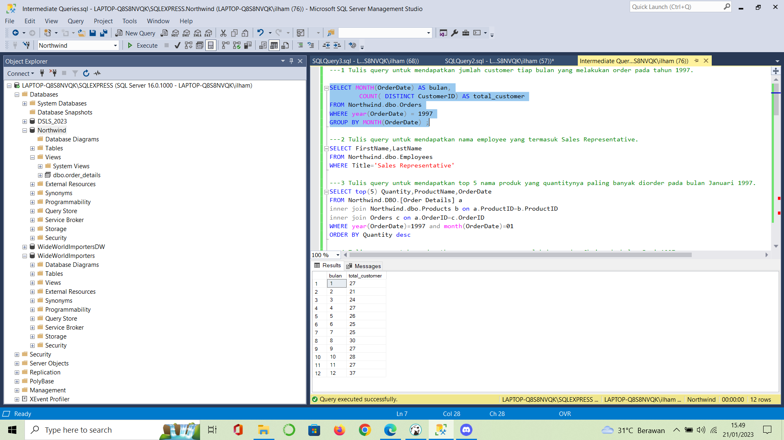

---2 Tulis query untuk mendapatkan nama employee yang termasuk Sales Representative.

SELECT FirstName,LastName

FROM Northwind.dbo.Employees

WHERE Title='Sales Representative'

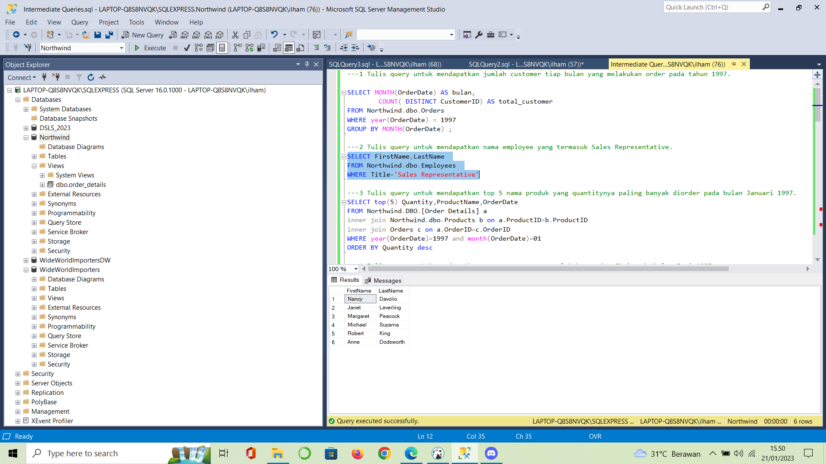

---3 Tulis query untuk mendapatkan top 5 nama produk yang quantitynya paling banyak diorder pada bulan Januari 1997.

SELECT top(5) Quantity,ProductName,OrderDate

FROM Northwind.DBO.[Order Details] a

inner join Northwind.dbo.Products b on a.ProductID=b.ProductID

inner join Orders c on a.OrderID=c.OrderID

WHERE year(OrderDate)=1997 and month(OrderDate)=01

ORDER BY Quantity desc

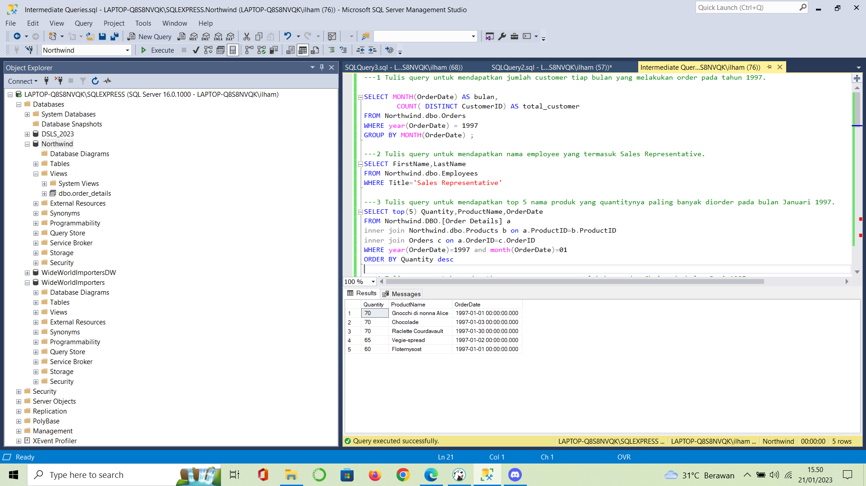

---4 Tulis query untuk mendapatkan nama company yang melakukan order Chai pada bulan Juni 1997.

SELECT ProductName,CompanyName, OrderDate

FROM Northwind.DBO.[Order Details] a

inner join Northwind.dbo.Products b on a.ProductID=b.ProductID

inner join Orders c on a.OrderID=c.OrderID

inner join Customers d on c.CustomerID =d.CustomerID

WHERE year(OrderDate)=1997 and month(OrderDate)=06 and ProductName='Chai'

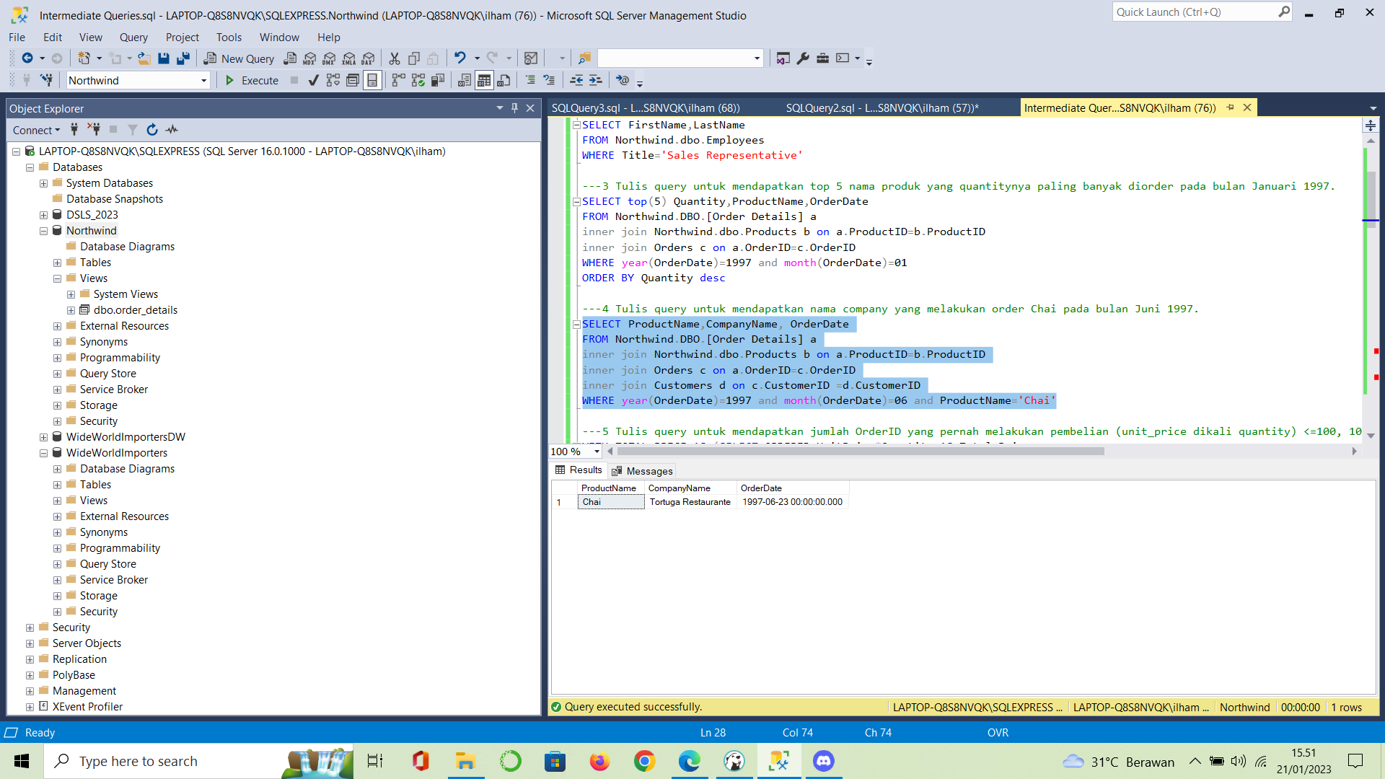

---5 Tulis query untuk mendapatkan jumlah OrderID yang pernah melakukan pembelian (unit_price dikali quantity) <=100, 100<x<=250, 250<x<=500, dan >500.

WITH TOTAL_PRICE AS (SELECT ORDERID,UnitPrice*Quantity AS Total_Price

FROM [Order Details]),

category_price as(select *,

case when Total_Price <=100 then '<=100'

when Total_Price >100 and Total_Price <= 250 then '100<x<=250'

when Total_Price >250 and Total_Price <= 500 then '250<x<=500'

else '>500' end as category

from TOTAL_PRICE)

select count(distinct OrderID) as total_orderID, category from category_price group by category

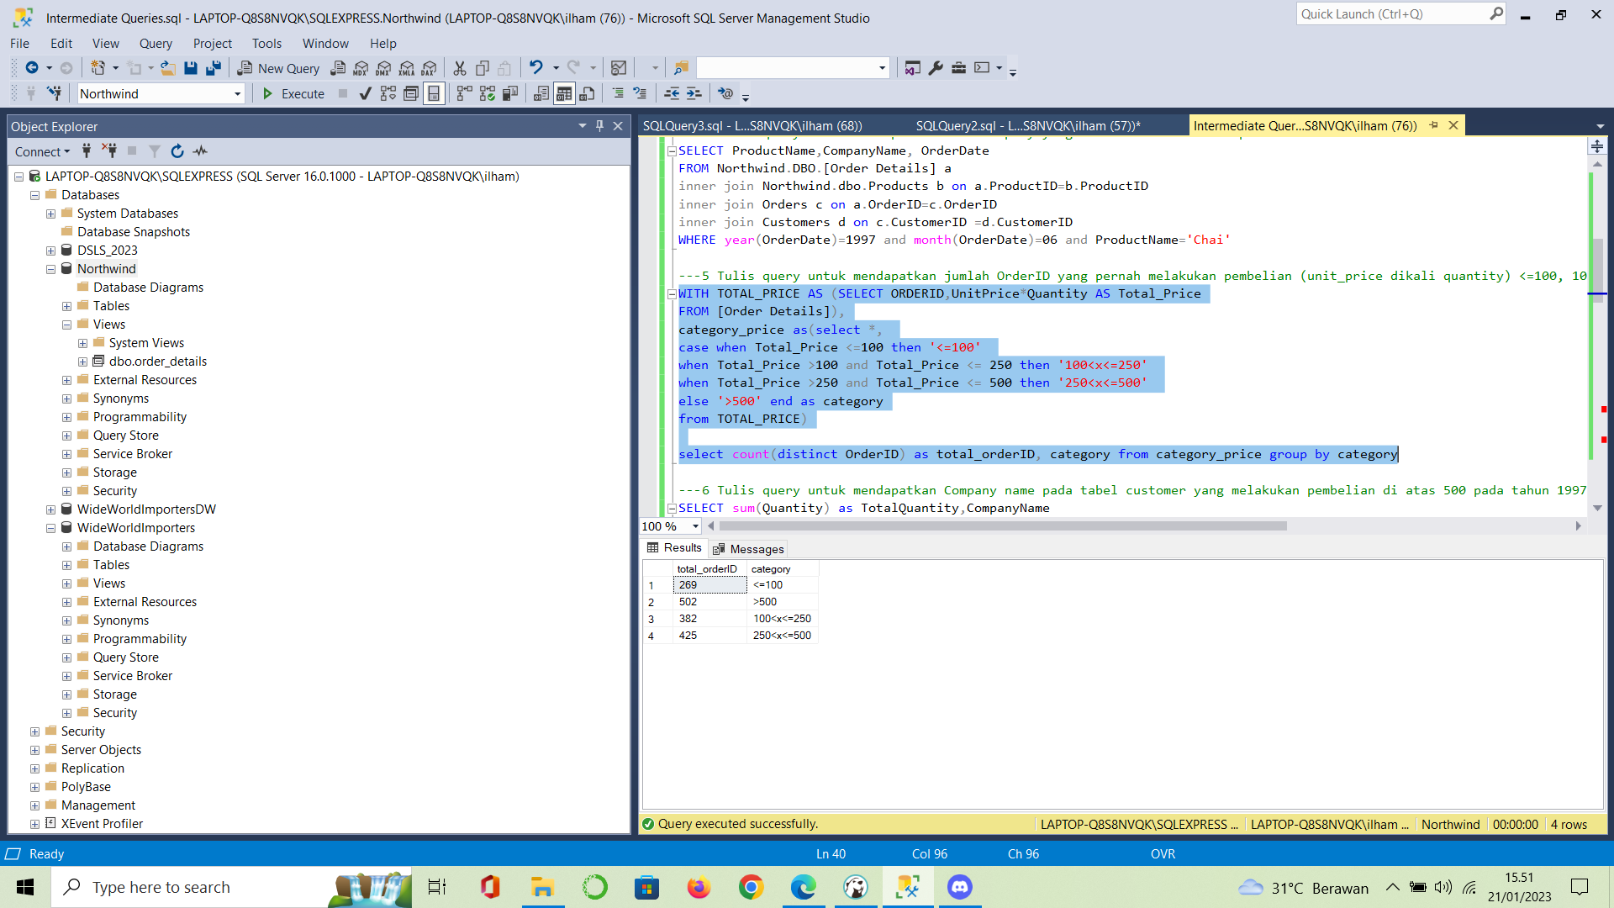

---6 Tulis query untuk mendapatkan Company name pada tabel customer yang melakukan pembelian di atas 500 pada tahun 1997.

SELECT sum(Quantity) as TotalQuantity,CompanyName

FROM Northwind.DBO.[Order Details] a

inner join Northwind.dbo.Products b on a.ProductID=b.ProductID

inner join Orders c on a.OrderID=c.OrderID

inner join Customers d on c.CustomerID =d.CustomerID

WHERE year(OrderDate)=1997

group by CompanyName

having sum(Quantity)>500

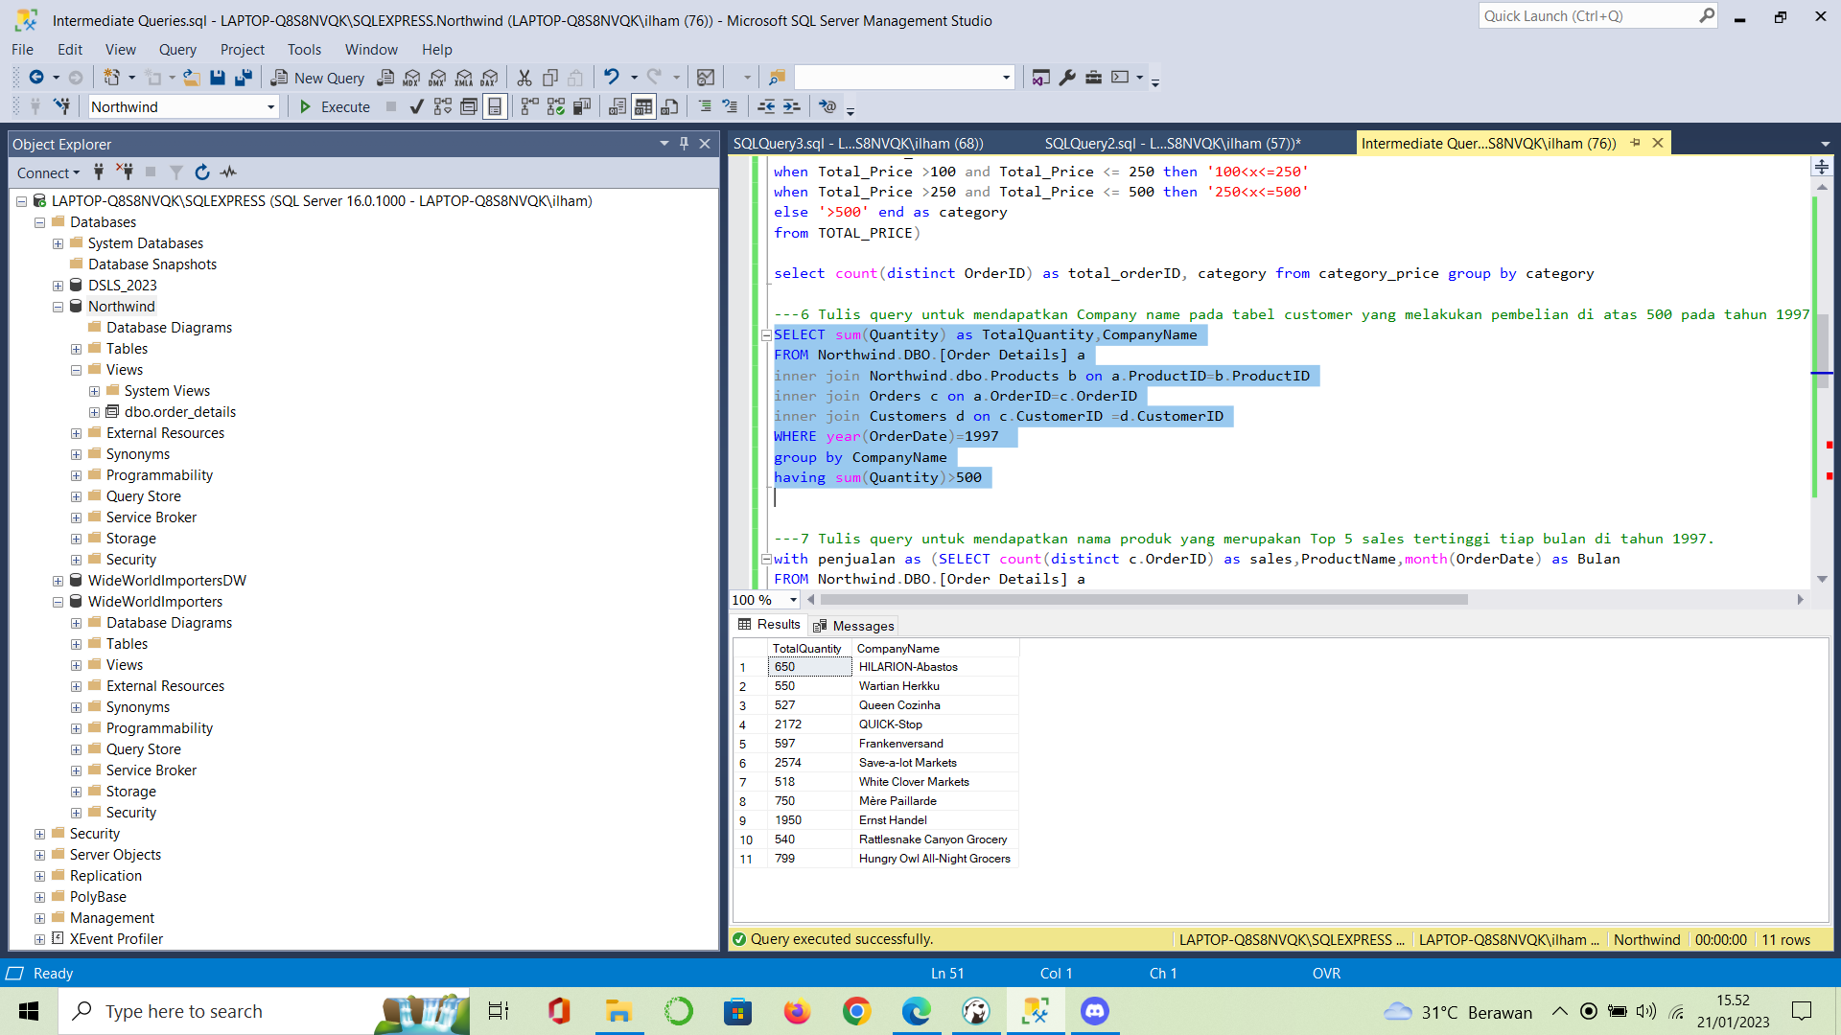

---7 Tulis query untuk mendapatkan nama produk yang merupakan Top 5 sales tertinggi tiap bulan di tahun 1997.

with penjualan as (SELECT count(distinct c.OrderID) as sales,ProductName,month(OrderDate) as Bulan

FROM Northwind.DBO.[Order Details] a

inner join Northwind.dbo.Products b on a.ProductID=b.ProductID

inner join Orders c on a.OrderID=c.OrderID

inner join Customers d on c.CustomerID =d.CustomerID

where year(OrderDate)=1997

group by ProductName,month(OrderDate))

SELECT *

FROM

(SELECT sales,ProductName, ROW_NUMBER() OVER(PARTITION BY Bulan ORDER BY sales desc) AS Ranking,Bulan

FROM penjualan

)as a

where Ranking in (1,2,3,4,5)

order by Bulan, Ranking

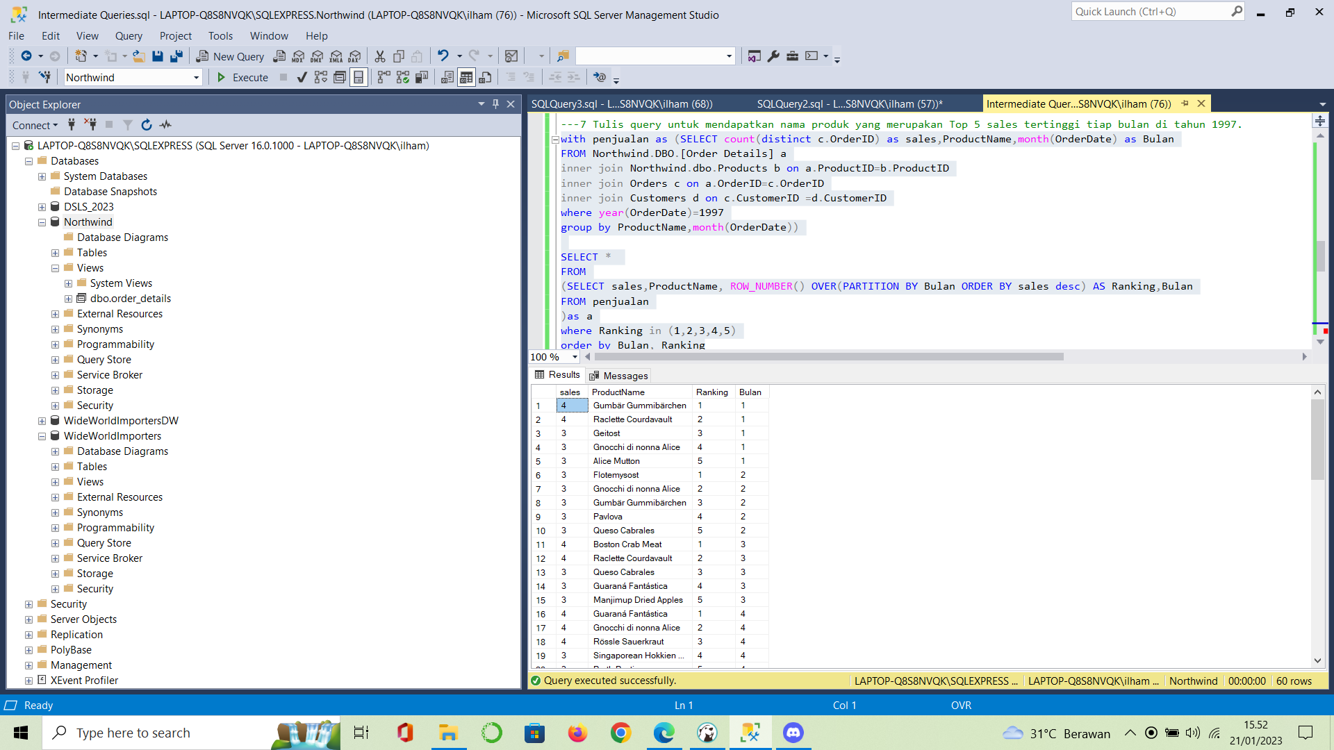

---8 Buatlah view untuk melihat Order Details yang berisi OrderID, ProductID, ProductName, UnitPrice, Quantity, Discount, Harga setelah diskon.

create view order_details

as

SELECT OrderId,b.ProductID, ProductName,a.UnitPrice,Quantity,a.Discount, (a.UnitPrice*(1-Discount)) as Price_AfterDiskon

FROM Northwind.DBO.[Order Details] a

inner join Northwind.dbo.Products b on a.ProductID=b.ProductID

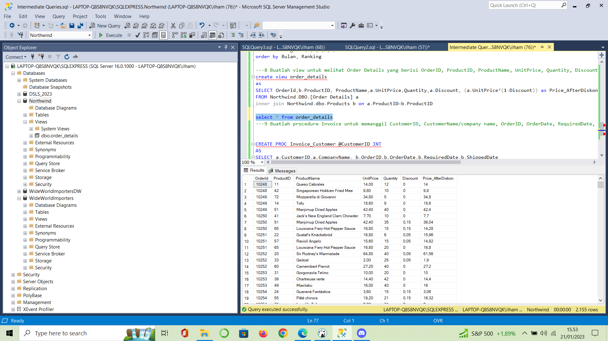

---9 Buatlah procedure Invoice untuk memanggil CustomerID, CustomerName/company name, OrderID, OrderDate, RequiredDate, ShippedDate jika terdapat inputan CustomerID tertentu.

CREATE PROC Invoice_CustomerId @CustomerID Varchar(50)

AS

SELECT a.CustomerID,a.CompanyName, b.OrderID,b.OrderDate,b.RequiredDate,b.ShippedDate

FROM Customers a

inner join Orders b on a.CustomerID=b.CustomerID

WHERE a.CustomerID = @CustomerID

